jQuery Mobile天气预报的实现

苏一桐 1801210879

本项目在苏东航同学文档的基础进行了一丢丢改进，包括：

1. 使用jQuery Mobile实现了前端的页面
2. 增加了微信经纬度到百度经纬度的转换，提高了定位的准确度
3. 对于天气信息的查询，不从本地数据库中去查而是使用API获取，增加未来的可扩展性
4. 增加了未来三天的天气展示（其实跟一天展示没啥区别2333）

**项目效果**

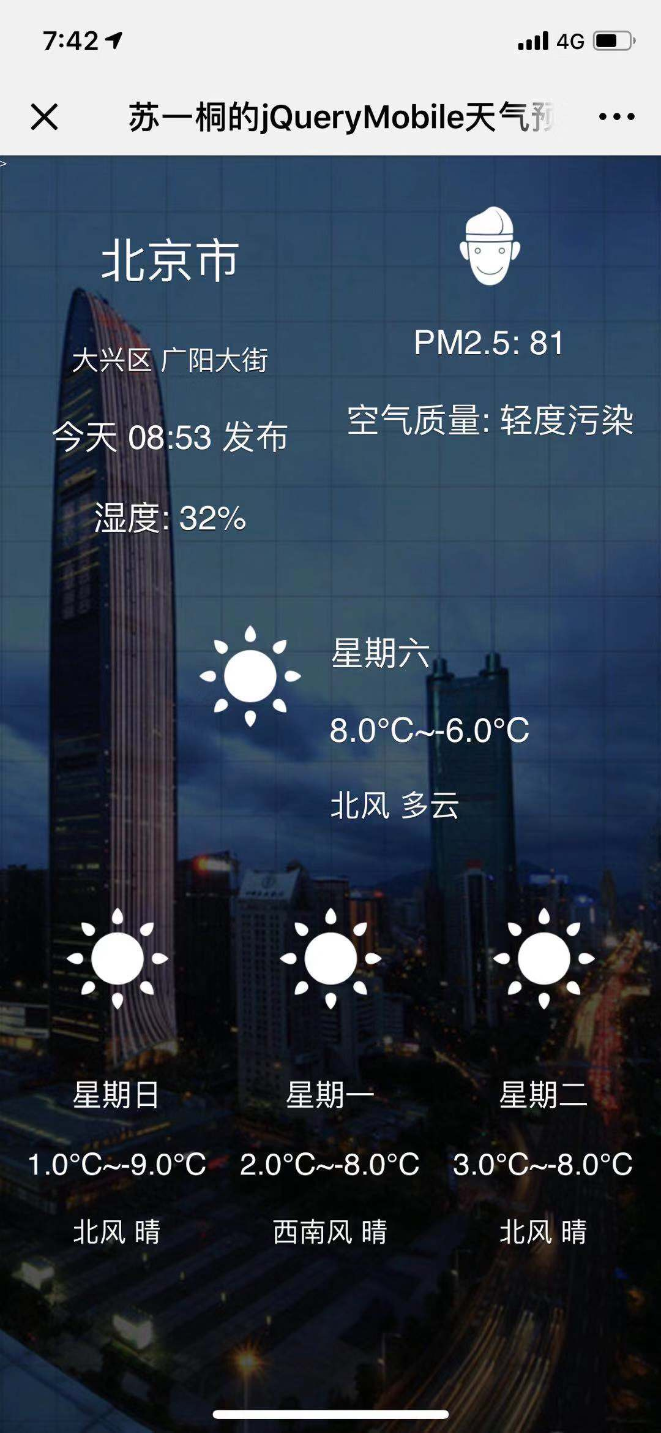

**项目分析**

简单来说，要完成这个项目，只需要三步：

1、写一个jQuery Mobile的前端页面。

2、使用JSSDK获取用户的经纬度。

3、编写Ajax代码转换用户通过JSSDK获取的经纬度最终得到天气信息。

**具体步骤**

1、写一个jQuery Mobile的前端页面，从jQuery Mobile教学网站稍微看两眼就可以，可以将前端页面写成任何你想要的样式。实例样式如下，详细代码见文章末尾。

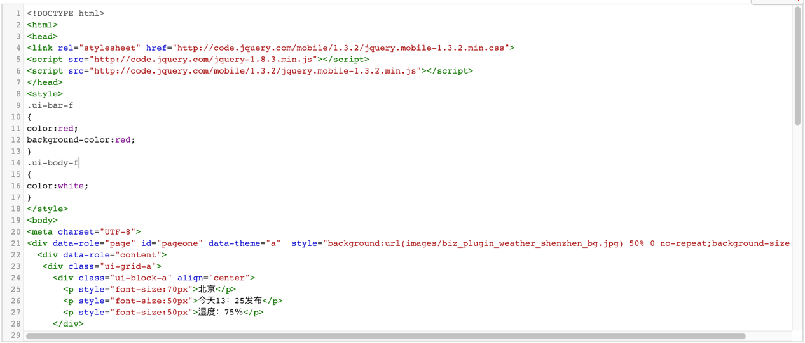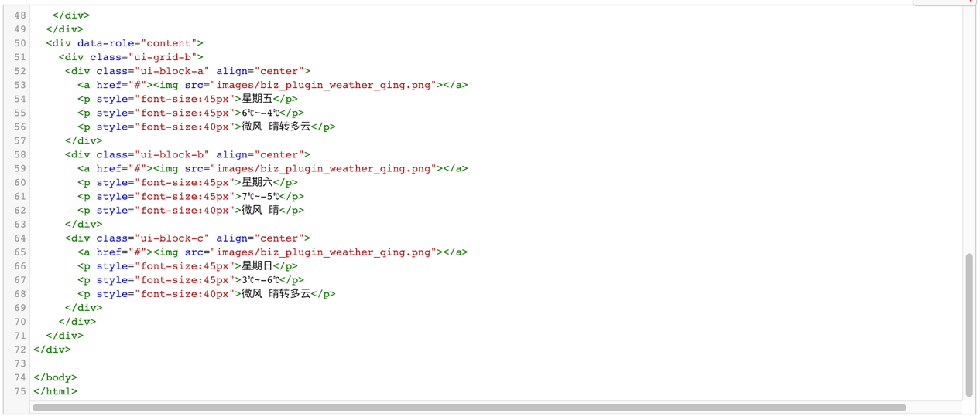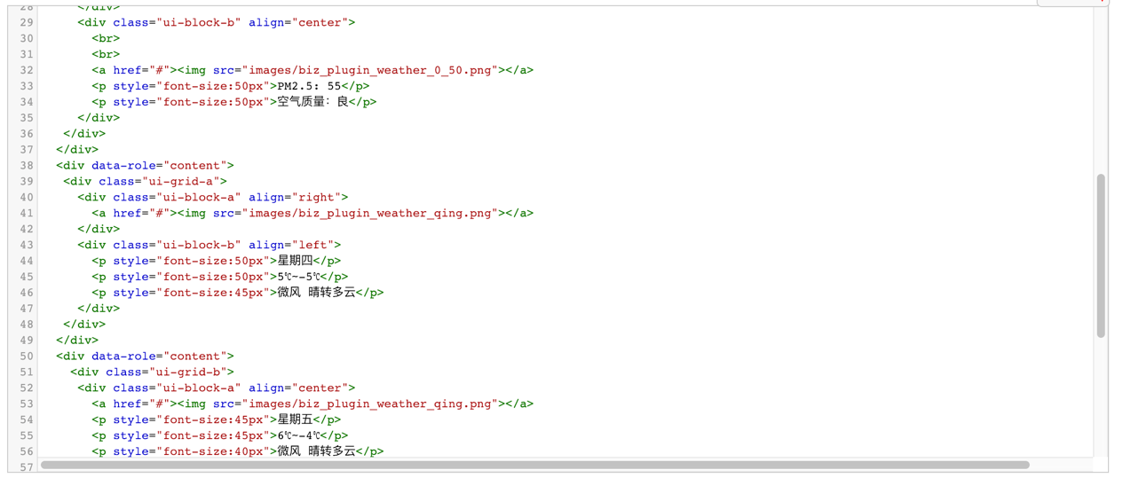

2、使用JSSDK获取用户的经纬度，这一步我们课上做过，即老师的sample.php代码，这里需要明确的知识点是：HTML文档是可以内嵌到PHP代码里面的。我们将写好的HTML内嵌到此PHP代码中即可，大家一定要注意嵌入的位置！JSSDK的代码是在HTML里面的单独的

script块里，也就是说，我们的JSSDK的业务代码是HTML的一部分，HTML代码在PHP代码的下方。

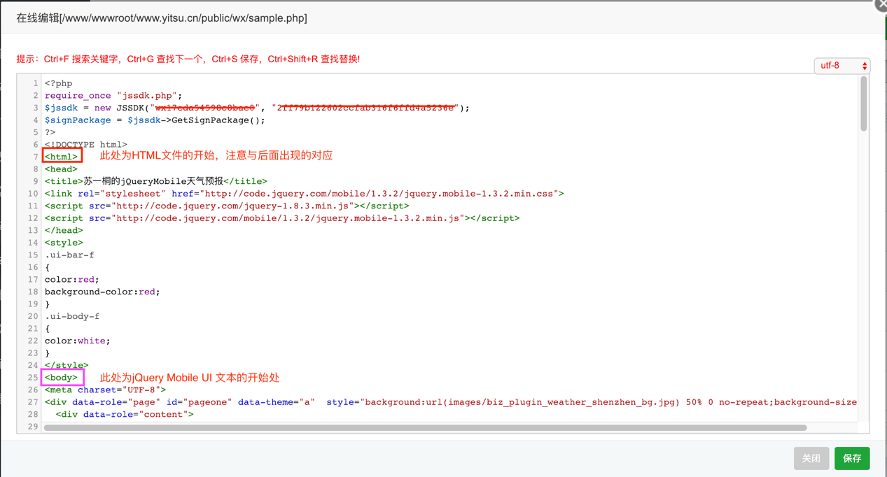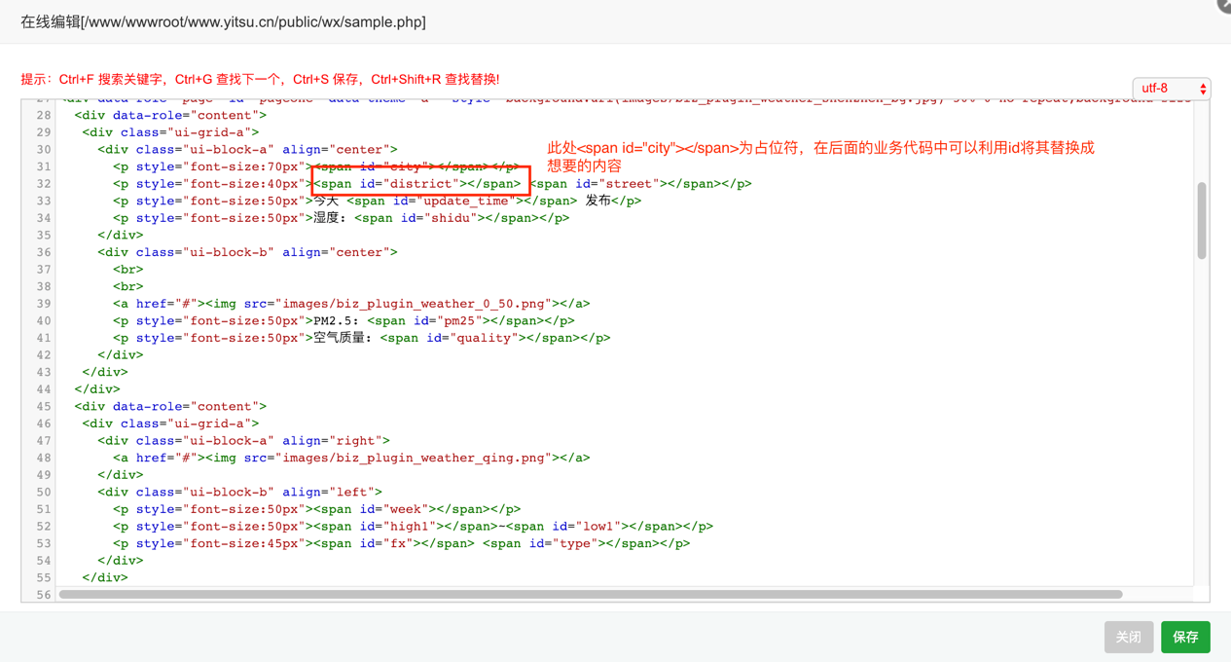

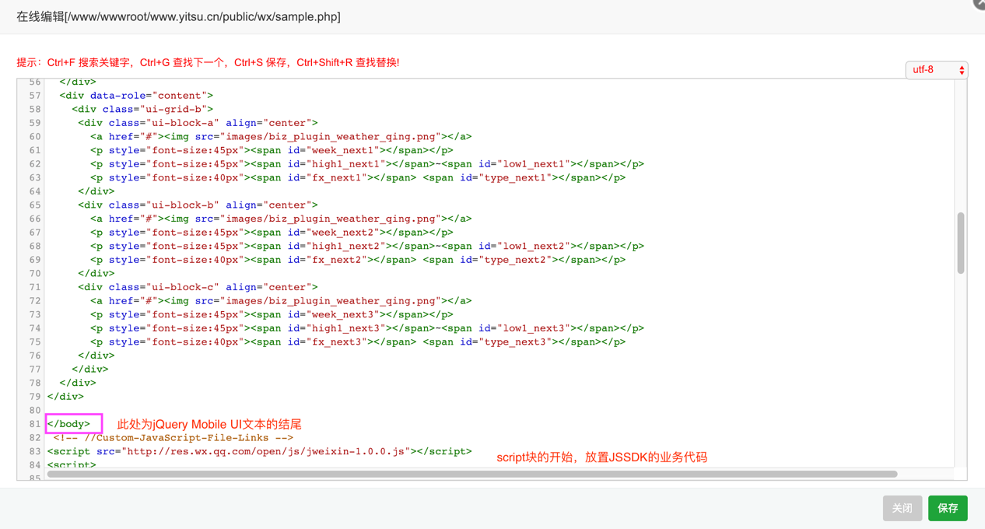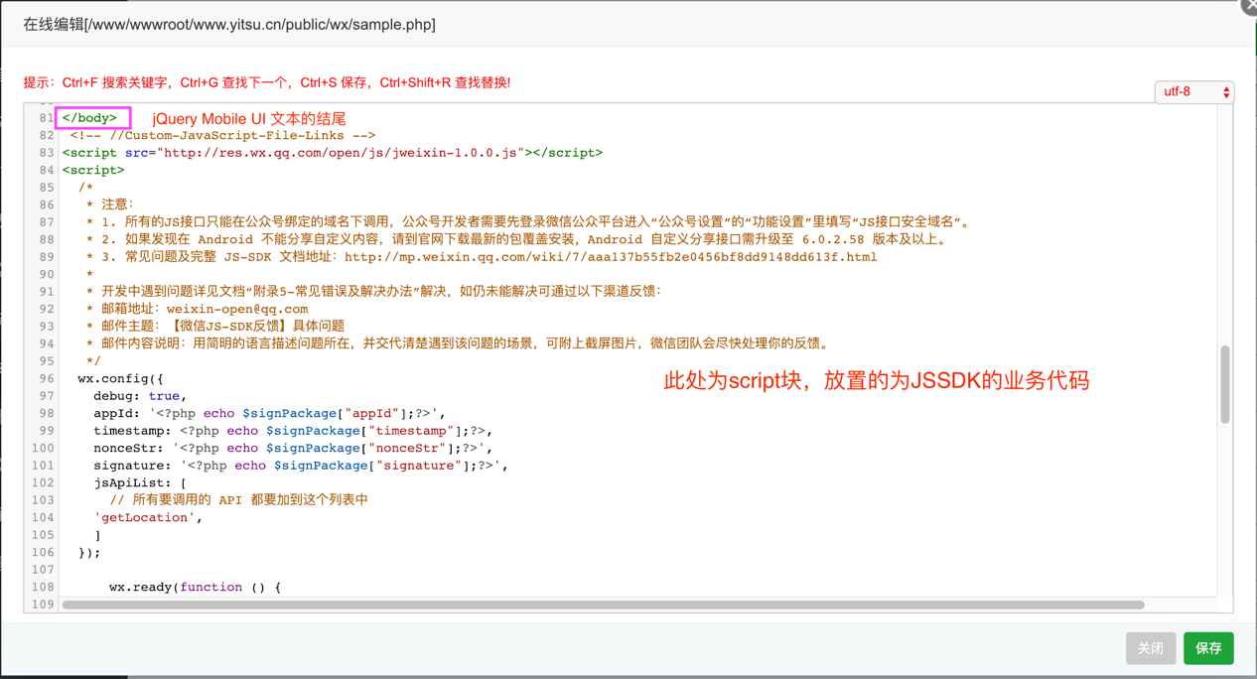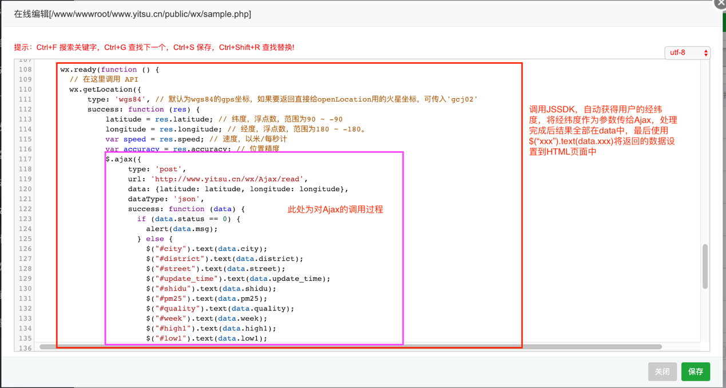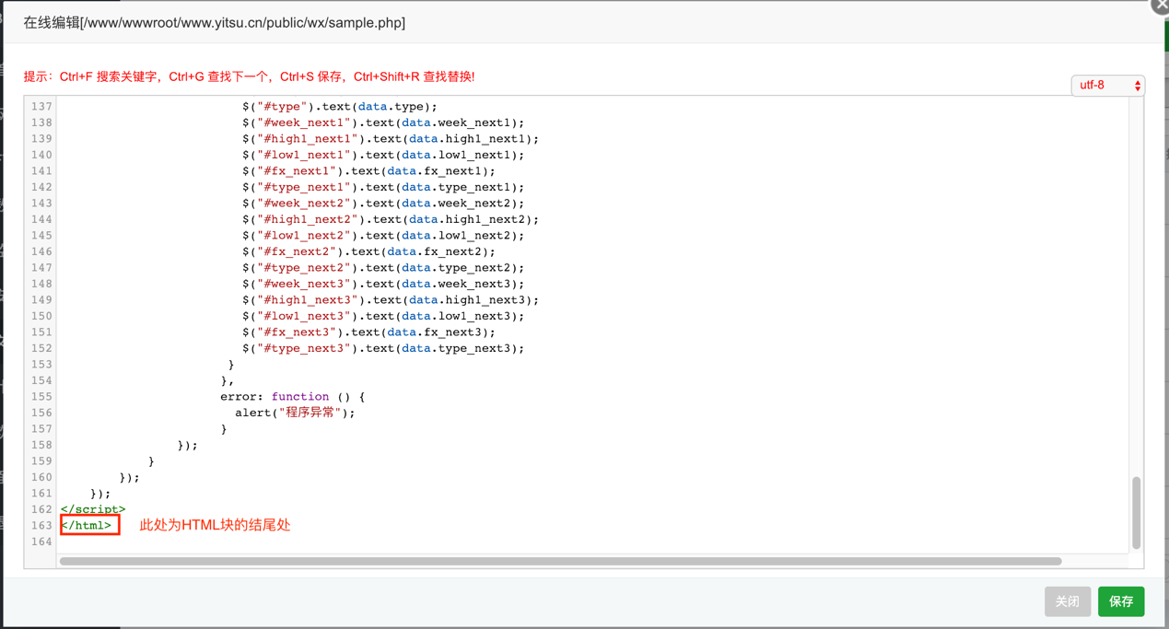

3、编写Ajax.php接收用户传过来的经纬度，得到最终的天气信息。我们已经知道，由于微信端所获取的经纬度与百度的经纬度测定方式不同，如果我们直接利用微信所获取的经纬度利用百度的逆地址编码转换城市和街道会导致一至两个街道的偏差，所以我们需要：

1．将微信的经纬度转换为百度的经纬度（利用百度API）

2．利用转换后的百度的经纬度获取城市（利用百度逆地址编码API）

3．利用我们之前开发的两个ThinkPHP的API将城市转换为城市编码并利用城市编码获取天气信息最后返回（利用我们自己的两个API，如果爬虫没写好的话可以使用老师所提供的天气API）

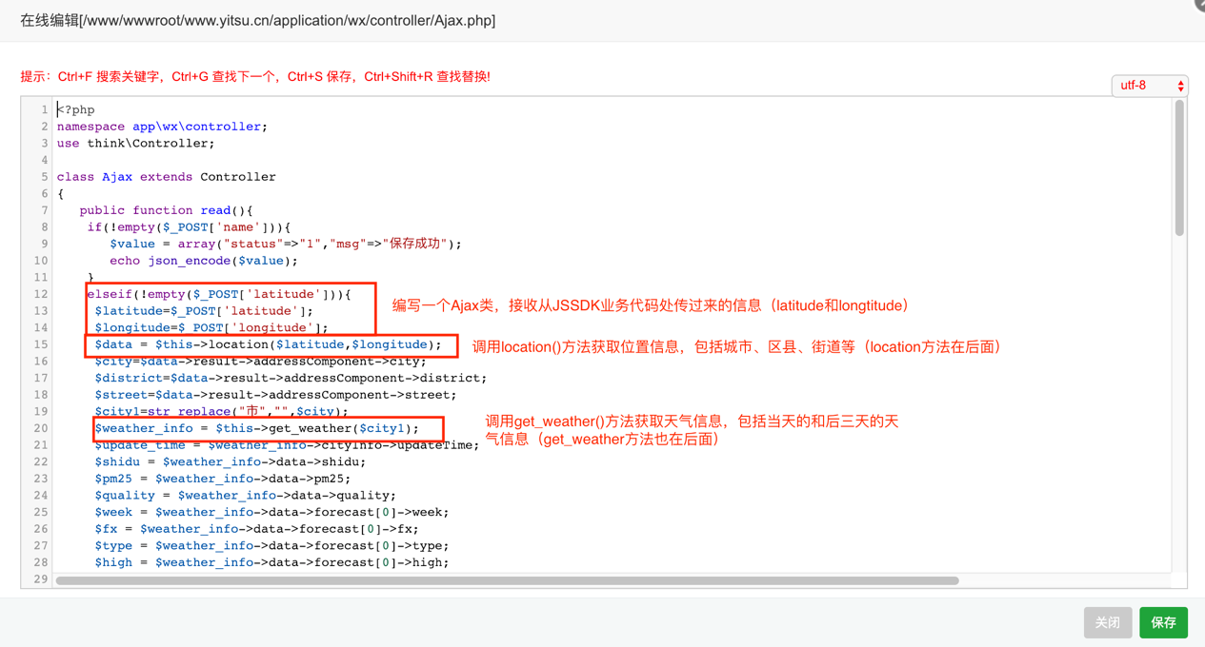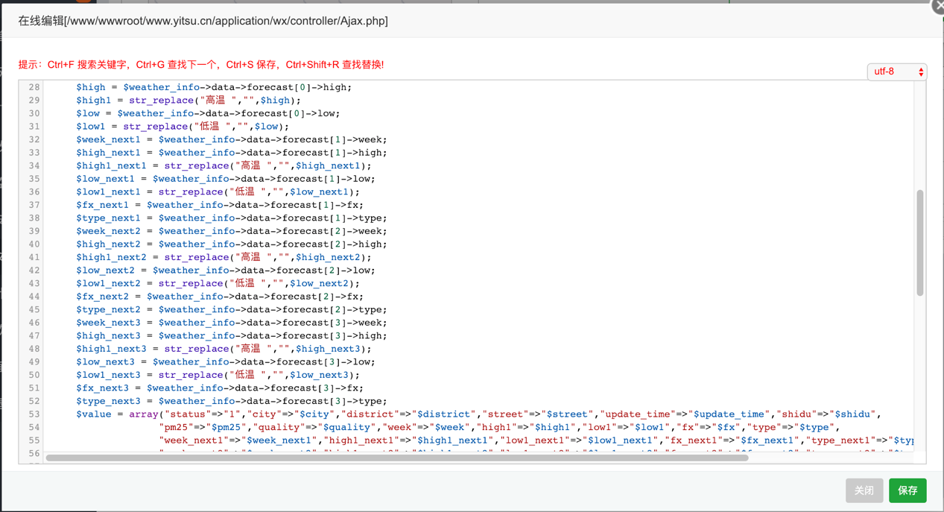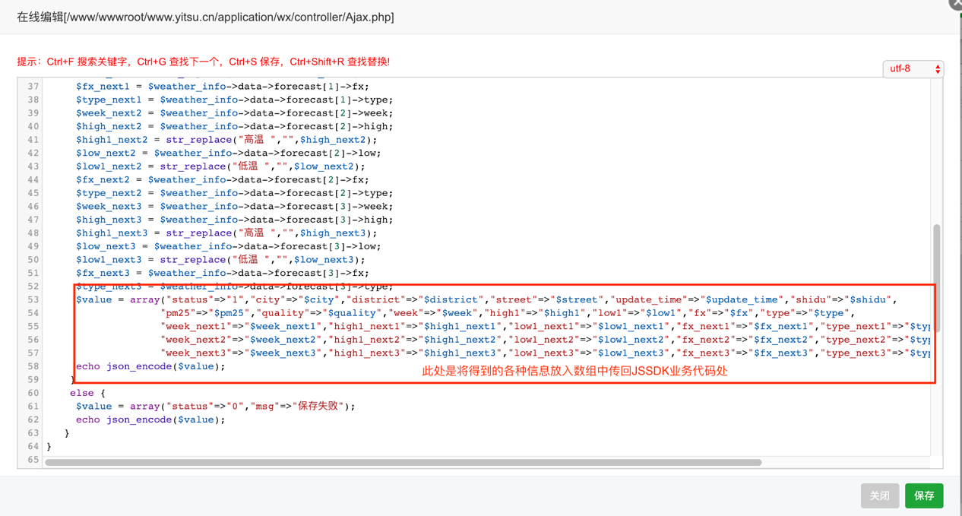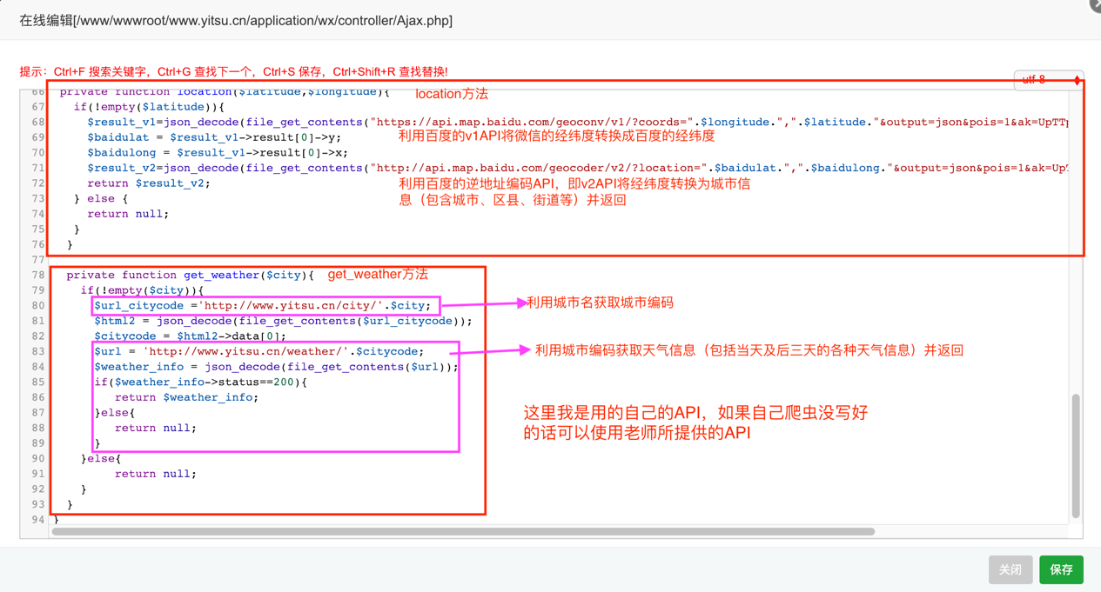

最终效果：



**完整代码：**

sample.php代码：

<?php

require_once "jssdk.php";

$jssdk = new JSSDK("wx17eda54598c8bae0", "2ff79b122602ccfab316f6ffd4a5236e");

$signPackage = $jssdk->GetSignPackage();

?>

<!DOCTYPE html>

<html>

<head>

<title>苏一桐的jQueryMobile天气预报</title>

<link rel="stylesheet" href="http://code.jquery.com/mobile/1.3.2/jquery.mobile-1.3.2.min.css">

<script src="http://code.jquery.com/jquery-1.8.3.min.js"></script>

<script src="http://code.jquery.com/mobile/1.3.2/jquery.mobile-1.3.2.min.js"></script>

</head>

<style>

.ui-bar-f

{

color:red;

background-color:red;

}

.ui-body-f

{

color:white;

}

</style>

<body>

<meta charset="UTF-8">

<div data-role="page" id="pageone" data-theme="a" style="background:url(images/biz_plugin_weather_shenzhen_bg.jpg) 50% 0 no-repeat;background-size:cover">>

<div data-role="content">

<div class="ui-grid-a">

<div class="ui-block-a" align="center">

<p style="font-size:70px"><span id="city"></span></p>

<p style="font-size:40px"><span id="district"></span> <span id="street"></span></p>

<p style="font-size:50px">今天 <span id="update_time"></span> 发布</p>

<p style="font-size:50px">湿度: <span id="shidu"></span></p>

</div>

<div class="ui-block-b" align="center">

<br>

<br>

<a href="#"><img src="images/biz_plugin_weather_0_50.png"></a>

<p style="font-size:50px">PM2.5: <span id="pm25"></span></p>

<p style="font-size:50px">空气质量: <span id="quality"></span></p>

</div>

</div>

</div>

<div data-role="content">

<div class="ui-grid-a">

<div class="ui-block-a" align="right">

<a href="#"><img src="images/biz_plugin_weather_qing.png"></a>

</div>

<div class="ui-block-b" align="left">

<p style="font-size:50px"><span id="week"></span></p>

<p style="font-size:50px"><span id="high1"></span>~<span id="low1"></span></p>

<p style="font-size:45px"><span id="fx"></span> <span id="type"></span></p>

</div>

</div>

</div>

<div data-role="content">

<div class="ui-grid-b">

<div class="ui-block-a" align="center">

<a href="#"><img src="images/biz_plugin_weather_qing.png"></a>

<p style="font-size:45px"><span id="week_next1"></span></p>

<p style="font-size:45px"><span id="high1_next1"></span>~<span id="low1_next1"></span></p>

<p style="font-size:40px"><span id="fx_next1"></span> <span id="type_next1"></span></p>

</div>

<div class="ui-block-b" align="center">

<a href="#"><img src="images/biz_plugin_weather_qing.png"></a>

<p style="font-size:45px"><span id="week_next2"></span></p>

<p style="font-size:45px"><span id="high1_next2"></span>~<span id="low1_next2"></span></p>

<p style="font-size:40px"><span id="fx_next2"></span> <span id="type_next2"></span></p>

</div>

<div class="ui-block-c" align="center">

<a href="#"><img src="images/biz_plugin_weather_qing.png"></a>

<p style="font-size:45px"><span id="week_next3"></span></p>

<p style="font-size:45px"><span id="high1_next3"></span>~<span id="low1_next3"></span></p>

<p style="font-size:40px"><span id="fx_next3"></span> <span id="type_next3"></span></p>

</div>

</div>

</div>

</div>

</body>

<!-- //Custom-JavaScript-File-Links -->

<script src="http://res.wx.qq.com/open/js/jweixin-1.0.0.js"></script>

<script>

/*

* 注意：

* 1. 所有的JS接口只能在公众号绑定的域名下调用，公众号开发者需要先登录微信公众平台进入“公众号设置”的“功能设置”里填写“JS接口安全域名”。

* 2. 如果发现在 Android 不能分享自定义内容，请到官网下载最新的包覆盖安装，Android 自定义分享接口需升级至 6.0.2.58 版本及以上。

* 3. 常见问题及完整 JS-SDK 文档地址：http://mp.weixin.qq.com/wiki/7/aaa137b55fb2e0456bf8dd9148dd613f.html

*

* 开发中遇到问题详见文档“附录5-常见错误及解决办法”解决，如仍未能解决可通过以下渠道反馈：

* 邮箱地址：weixin-open@qq.com

* 邮件主题：【微信JS-SDK反馈】具体问题

* 邮件内容说明：用简明的语言描述问题所在，并交代清楚遇到该问题的场景，可附上截屏图片，微信团队会尽快处理你的反馈。

*/

wx.config({

debug: true,

appId: '<?php echo $signPackage["appId"];?>',

timestamp: <?php echo $signPackage["timestamp"];?>,

nonceStr: '<?php echo $signPackage["nonceStr"];?>',

signature: '<?php echo $signPackage["signature"];?>',

jsApiList: [

// 所有要调用的 API 都要加到这个列表中

'getLocation',

]

});

wx.ready(function () {

// 在这里调用 API

wx.getLocation({

type: 'wgs84', // 默认为wgs84的gps坐标，如果要返回直接给openLocation用的火星坐标，可传入'gcj02'

success: function (res) {

latitude = res.latitude; // 纬度，浮点数，范围为90 ~ -90

longitude = res.longitude; // 经度，浮点数，范围为180 ~ -180。

var speed = res.speed; // 速度，以米/每秒计

var accuracy = res.accuracy; // 位置精度

$.ajax({

type: 'post',

url: 'http://www.yitsu.cn/wx/Ajax/read',

data: {latitude: latitude, longitude: longitude},

dataType: 'json',

success: function (data) {

if (data.status == 0) {

alert(data.msg);

} else {

$("#city").text(data.city);

$("#district").text(data.district);

$("#street").text(data.street);

$("#update_time").text(data.update_time);

$("#shidu").text(data.shidu);

$("#pm25").text(data.pm25);

$("#quality").text(data.quality);

$("#week").text(data.week);

$("#high1").text(data.high1);

$("#low1").text(data.low1);

$("#fx").text(data.fx);

$("#type").text(data.type);

$("#week_next1").text(data.week_next1);

$("#high1_next1").text(data.high1_next1);

$("#low1_next1").text(data.low1_next1);

$("#fx_next1").text(data.fx_next1);

$("#type_next1").text(data.type_next1);

$("#week_next2").text(data.week_next2);

$("#high1_next2").text(data.high1_next2);

$("#low1_next2").text(data.low1_next2);

$("#fx_next2").text(data.fx_next2);

$("#type_next2").text(data.type_next2);

$("#week_next3").text(data.week_next3);

$("#high1_next3").text(data.high1_next3);

$("#low1_next3").text(data.low1_next3);

$("#fx_next3").text(data.fx_next3);

$("#type_next3").text(data.type_next3);

}

},

error: function () {

alert("程序异常");

}

});

}

});

});

</script>

</html>

Ajax.php代码：

<?php

namespace app\wx\controller;

use think\Controller;

class Ajax extends Controller

{

public function read(){

if(!empty($_POST['name'])){

$value = array("status"=>"1","msg"=>"保存成功");

echo json_encode($value);

}

elseif(!empty($_POST['latitude'])){

$latitude=$_POST['latitude'];

$longitude=$_POST['longitude'];

$data = $this->location($latitude,$longitude);

$city=$data->result->addressComponent->city;

$district=$data->result->addressComponent->district;

$street=$data->result->addressComponent->street;

$city1=str_replace("市","",$city);

$weather_info = $this->get_weather($city1);

$update_time = $weather_info->cityInfo->updateTime;

$shidu = $weather_info->data->shidu;

$pm25 = $weather_info->data->pm25;

$quality = $weather_info->data->quality;

$week = $weather_info->data->forecast[0]->week;

$fx = $weather_info->data->forecast[0]->fx;

$type = $weather_info->data->forecast[0]->type;

$high = $weather_info->data->forecast[0]->high;

$high1 = str_replace("高温 ","",$high);

$low = $weather_info->data->forecast[0]->low;

$low1 = str_replace("低温 ","",$low);

$week_next1 = $weather_info->data->forecast[1]->week;

$high_next1 = $weather_info->data->forecast[1]->high;

$high1_next1 = str_replace("高温 ","",$high_next1);

$low_next1 = $weather_info->data->forecast[1]->low;

$low1_next1 = str_replace("低温 ","",$low_next1);

$fx_next1 = $weather_info->data->forecast[1]->fx;

$type_next1 = $weather_info->data->forecast[1]->type;

$week_next2 = $weather_info->data->forecast[2]->week;

$high_next2 = $weather_info->data->forecast[2]->high;

$high1_next2 = str_replace("高温 ","",$high_next2);

$low_next2 = $weather_info->data->forecast[2]->low;

$low1_next2 = str_replace("低温 ","",$low_next2);

$fx_next2 = $weather_info->data->forecast[2]->fx;

$type_next2 = $weather_info->data->forecast[2]->type;

$week_next3 = $weather_info->data->forecast[3]->week;

$high_next3 = $weather_info->data->forecast[3]->high;

$high1_next3 = str_replace("高温 ","",$high_next3);

$low_next3 = $weather_info->data->forecast[3]->low;

$low1_next3 = str_replace("低温 ","",$low_next3);

$fx_next3 = $weather_info->data->forecast[3]->fx;

$type_next3 = $weather_info->data->forecast[3]->type;

$value = array("status"=>"1","city"=>"$city","district"=>"$district","street"=>"$street","update_time"=>"$update_time","shidu"=>"$shidu",

"pm25"=>"$pm25","quality"=>"$quality","week"=>"$week","high1"=>"$high1","low1"=>"$low1","fx"=>"$fx","type"=>"$type",

"week_next1"=>"$week_next1","high1_next1"=>"$high1_next1","low1_next1"=>"$low1_next1","fx_next1"=>"$fx_next1","type_next1"=>"$type_next1",

"week_next2"=>"$week_next2","high1_next2"=>"$high1_next2","low1_next2"=>"$low1_next2","fx_next2"=>"$fx_next2","type_next2"=>"$type_next2",

"week_next3"=>"$week_next3","high1_next3"=>"$high1_next3","low1_next3"=>"$low1_next3","fx_next3"=>"$fx_next3","type_next3"=>"$type_next3");

echo json_encode($value);

}

else {

$value = array("status"=>"0","msg"=>"保存失败");

echo json_encode($value);

}

}

private function location($latitude,$longitude){

if(!empty($latitude)){

$result_v1=json_decode(file_get_contents("https://api.map.baidu.com/geoconv/v1/?coords=".$longitude.",".$latitude."&output=json&pois=1&ak=UpTTp4ViBfT0PgE3NzQtg0cUW6Bmg9BZ"));

$baidulat = $result_v1->result[0]->y;

$baidulong = $result_v1->result[0]->x;

$result_v2=json_decode(file_get_contents("http://api.map.baidu.com/geocoder/v2/?location=".$baidulat.",".$baidulong."&output=json&pois=1&ak=UpTTp4ViBfT0PgE3NzQtg0cUW6Bmg9BZ"));

return $result_v2;

} else {

return null;

}

}

private function get_weather($city){

if(!empty($city)){

$url_citycode ='http://www.yitsu.cn/city/'.$city;

$html2 = json_decode(file_get_contents($url_citycode));

$citycode = $html2->data[0];

$url = 'http://www.yitsu.cn/weather/'.$citycode;

$weather_info = json_decode(file_get_contents($url));

if($weather_info->status==200){

return $weather_info;

}else{

return null;

}

}else{

return null;

}

}

}